
SRM Institute of Science and Technology
Mode of Exam
OFFLINE
College of Engineering and Technology
School of Computing
DEPARTMENT OF COMPUTING TECHNOLOGIES
SRM Nagar, Kattankulathur – 603203, Chengalpattu District, Tamilnadu
Academic Year: 2022-2023 (ODD)
Test: CLAT-1 Date: 22.02.2023
Course Code & Title: 18CSC305J– Artificial Intelligence Duration: 9.45 am– 10.45 am
Year & Sem: III/V Max. Marks: 25

Course Articulation Matrix:
CO | PO1 | PO2 | PO3 | PO4 | PO5 | PO6 | PO7 | PO8 | PO9 | PO10 | PO11 | PO12
CO1 | M | M | M | M | H | - | - | - | M | L | - | H
CO2 | M | H | H | H | H | - | - | - | M | L | - | H
CO3 | M | H | H | M | H | - | - | - | M | L | - | H
CO4 | M | H | M | H | H | - | - | - | M | L | - | H
CO5 | M | H | H | H | H | - | - | - | M | L | - | H
CO6 | L | H | M | M | H | - | - | - | H | L | - | H

Part - A
( 10 x 1 = Marks)
Instructions: Answer all
Q. No | Question | Marks | BL | CO | PO | PI Code
1 | Which of the following is not a heuristic way?  - To discover something or an idea embedded in a program  - To search and measure how far a node in a search tree seems to be from a goal  - To compare two nodes in a search tree to see if one is better than the other is  - Exploring the state space without considering the cost of reaching the goal  Ans : d | 1 | 1 | 1 | 1 | 1.6.1
2 | The extraction of meaningful information that is previously unknown and can be very useful potential ahead is known as  - Knowledge Discovery  - Machine Learning  - Learning Theory  - Neural Computation | 1 | 1 | 1 | 1 | 1.6.1
3 | Which model is based on sign processes or signification and communication?  - Syntactic  - Semantic  - Semiotic  - Statistical | 1 | 2 | 1 | 1 | 1.6.1
4 | The process of removing detail from a given state representation is called  - Extraction  - Abstraction  - Information retrieval  - Mining of data | 1 | 1 | 1 | 1 | 1.6.1
5 | Choose the correct: A) knowledge base (KB) consists of a set of statements. B) Inference is deriving a new sentence from the KB.  - A is true, B is true  - A is false, B is false  - A is true, B is false  - A is false, B is true | 1 | 2 | 1 | 1 | 1.6.1
6 | Treatment given by doctor for a patient to treat a disease is based on  - Only current symptoms  - Current symptoms plus some knowledge from the textbooks  - Current symptoms plus some knowledge from the textbooks plus experience  - some knowledge from the textbooks plus experience | 1 | 2 | 1 | 1 | 1.6.1
7 | What happens when the backtracking calculation arrives at a solution?  - It backtracks to the root  - It continues searching for other possible solutions  - It traverses from a different route  - Recursively traverses through the same route | 1 | 1 | 1 | 2 | 1.6.1
8 | Which environment cannot be changed while the agent is deliberating?  - Static  - Stochastic  - internal state  - percept | 1 | 2 | 1 | 2 | 1.6.1
9 | The following diagram is the representation _________ in state space of 4 – queen’s problems.  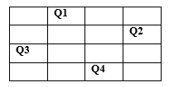  a) Initial state  b) Intermediate state  c) Goal State  d) Path | 1 | 2 | 1 | 1 | 1.6.1
10 | Constraints are the ones that restrict  - Movement  - Arrangement  - Possibilities  - Solutions  - 1,3  - 1,2,3,4  - 2,4  - 1,3,4 | 1 | 2 | 1 | 1 | 1.6.1
Part – B
( 3 x 5 = Marks)
Instructions: Answer any 3
11 | Discuss about the Problem Formulation for Vacuum Cleaner World.  Assume that the agent knows its location and the locations of all the pieces of dirt, and the suction is still in good working order.  • States: one of the eight states  • Operators: move left, move right, suck.  • Goal test: no dirt left in any square.  • Path cost: each action costs 1.  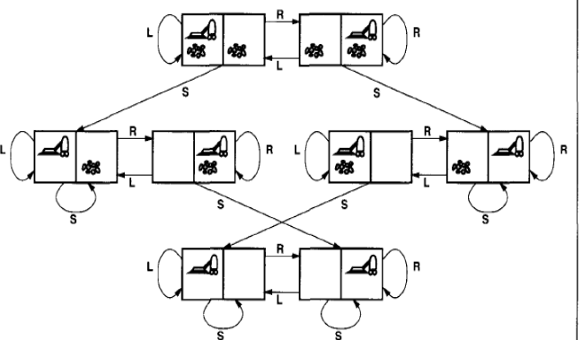 | 5 | 3 | 1 | 2 | 1.6.1
12 | Solve the following cryptoarithmetic puzzle  - EAT + THAT = APPLE (2.5 marks)  3 digit number (EAT) + 4 digit number(THAT) = 5 digit number(APPLE)  If so, then A can be 1 and p can be 0.  Again here T is yielding a two digit number (10).  So there must be a carry 1 and T = 9.  Now the expression becomes  E 1 9  9 H 1 9  -------------  1 0 0 L E  Now it is clear that E = 8 and L = 3  So,A + T + L = 1 + 9 + 3 =13  - TWO + TWO = FOUR (2.5 marks)  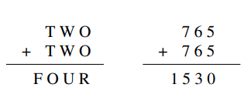 | 5 | 3 | 1 | 2 | 1.6.1
13 | Compare the Model based agent and goal based agent.  Model-based Reflex Agents (2.5 marks)  - Percept history is maintained (Using internal states)  - Agents reflect some of the unobserved aspects of the current state  - Incorporating things in determining the unobserved aspects is called model  - Model keeps track the past sequence of percept to determine the unseen part and impact of actions on environment  - Model-based intelligent agents have wide applications  compared to simple reflex agents  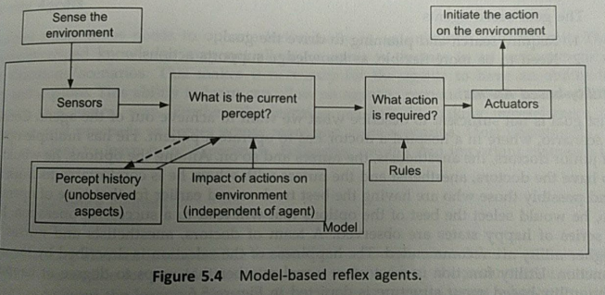  Goal based agent: (2.5 marks)  Goal of Decision-Making is considered  - Goal based action is very complicated and need a sequence of  - actions  - Decision-Making checks the impact of actions with reference  - to the goal  - Less efficient but more flexible  - More time is required for reasoning process  - Resemblance of Model-Based agents  - Goal based agents require  - Require search and planning to drive the goal  - Need to be more flexible, as knowledge supports action  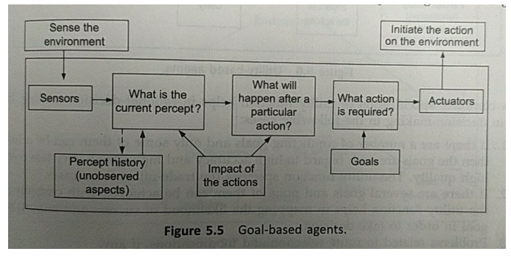 | 5 | 1 | 1 | 1 | 1.6.1
14 | Explain the concept of intelligent backtracking with example. (Explanation : 3 marks; Example : 2 marks)  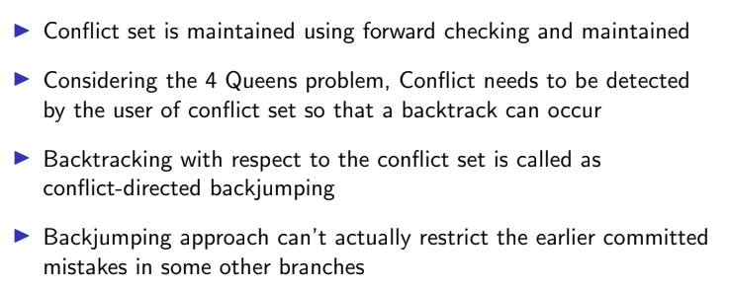 | 5 | 2 | 1 | 1 | 1.6.1

*Performance Indicators are available separately for Computer Science and Engineering in AICTE examination reforms policy.

Course Outcome (CO) and Bloom’s level (BL) Coverage in Questions

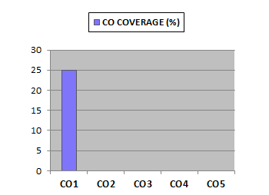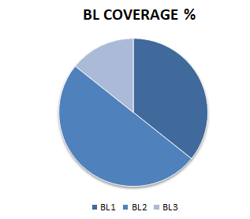

Approved by the Audit Professor/Course Coordinator

